HTML Body Element

📘 Definition
# Source: AI Source: Provided by: [Data Path: Persons Table -> ID Column: 1, Name_En Column: Motasem Essam] -> From: [ChatGPT] on [5/6/2026]
The <body> element contains all the visible content of a webpage that users see in the browser.
Everything you see on a website is inside the <body>.

👀 What goes inside <body>?
# Source: AI Source: Provided by: [Data Path: Persons Table -> ID Column: 1, Name_En Column: Motasem Essam] -> From: [ChatGPT] on [5/6/2026]
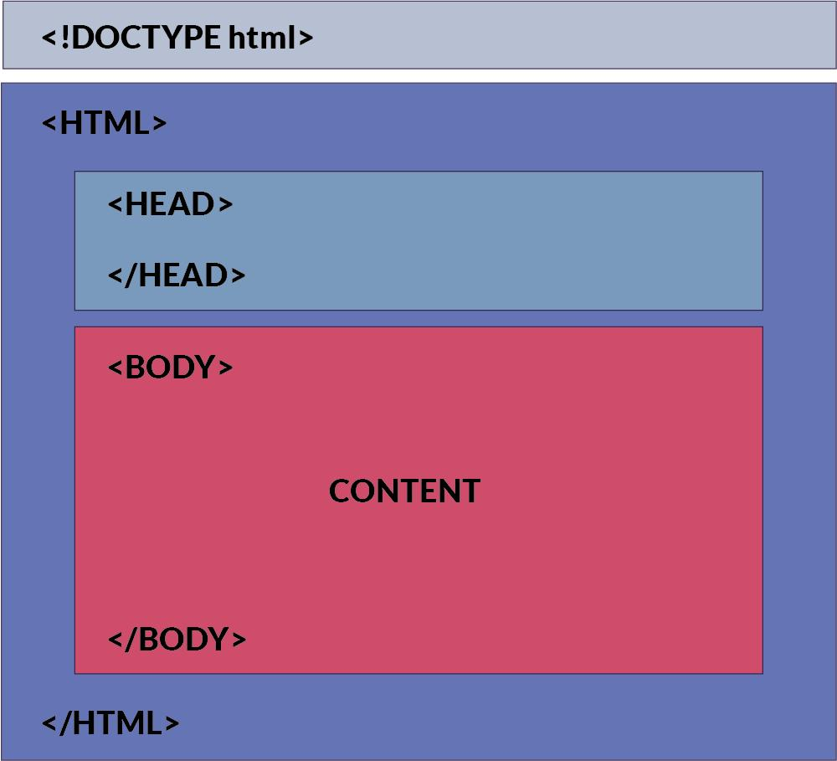
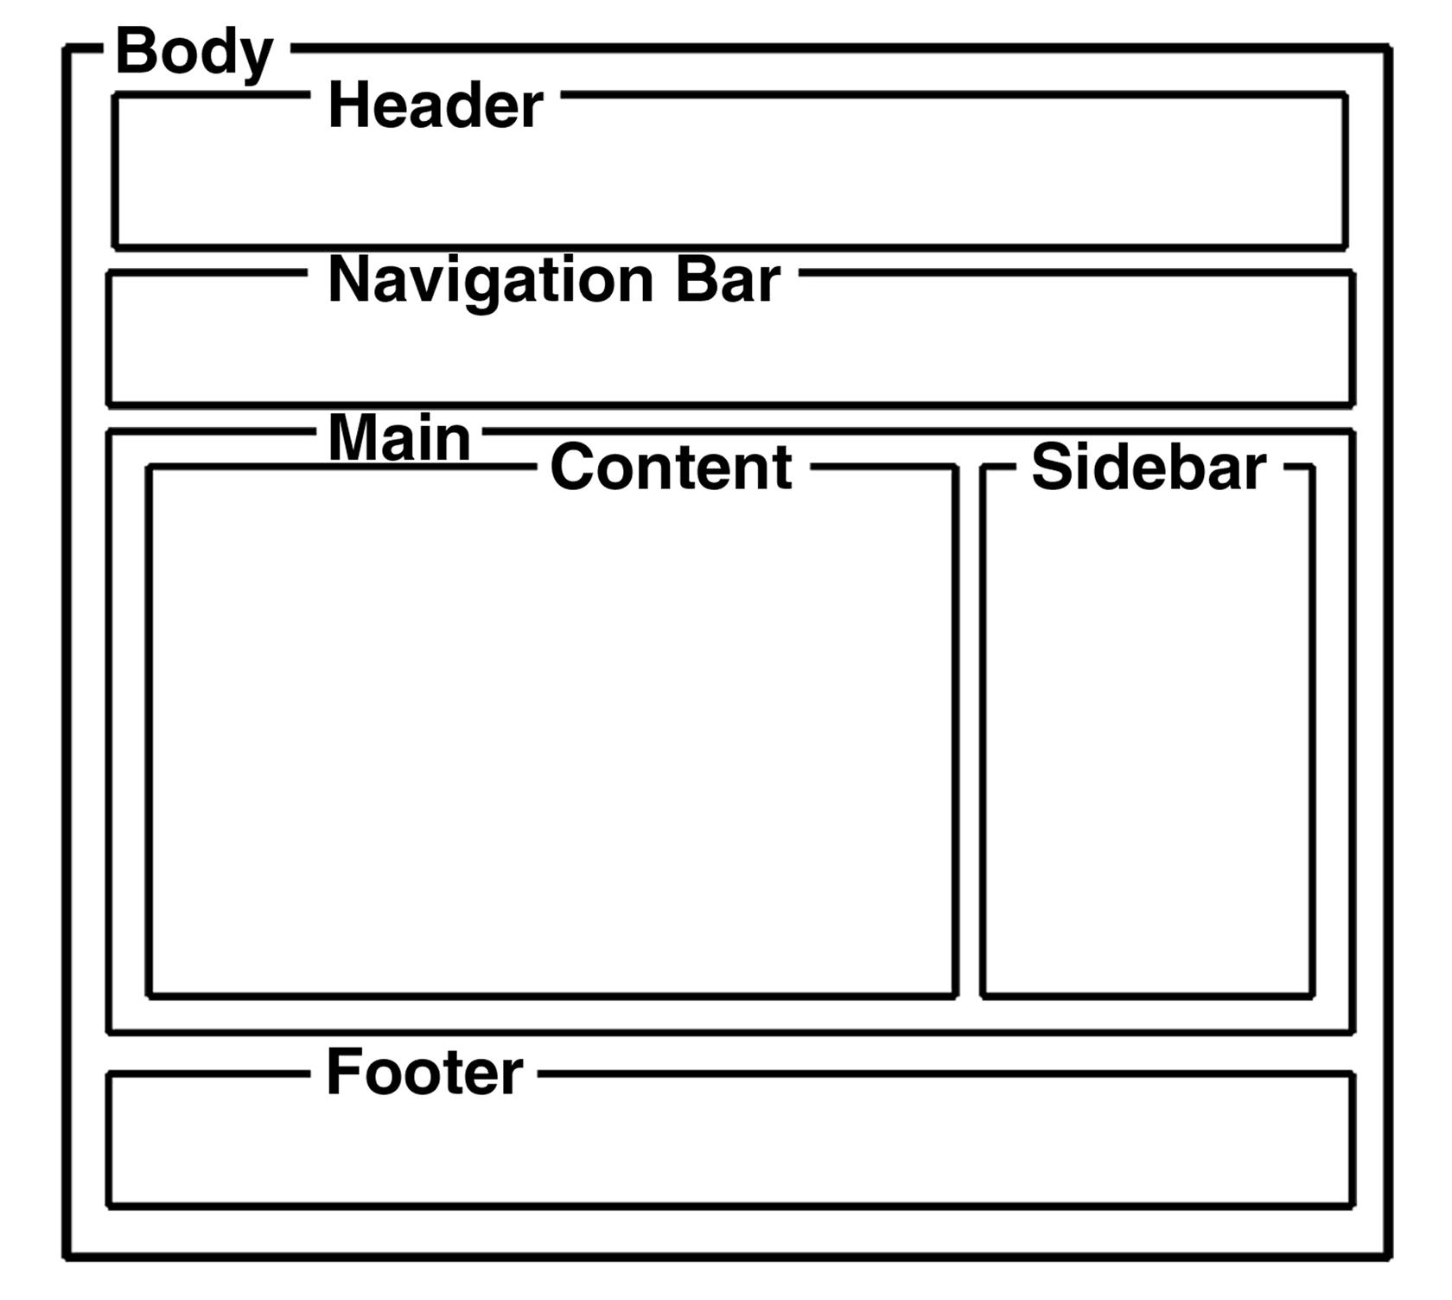
Inside <body> you can add:
- 📝 Text (headings, paragraphs)
- 🖼️ Images
- 🔗 Links
- 🎮 Buttons
- 🎬 Videos
- 📊 Forms

💻 Example of <body> element

Full Example
# Source: AI Source: Provided by: [Data Path: Persons Table -> ID Column: 1, Name_En Column: Motasem Essam] -> From: [ChatGPT] on [5/6/2026]
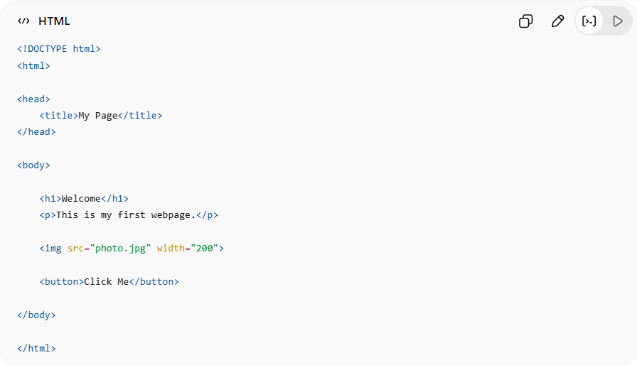
<!DOCTYPE html>
<html>

<head>
<title>My Page</title>
</head>

<body>

<h1>Welcome</h1>
<p>This is my first webpage.</p>

<img src="photo.jpg" width="200">

<button>Click Me</button>

</body>

</html>

Real Example
# Source: ScreenShot Source: Provided by: [Persons Table -> ID Column: 1, Name_En Column: Motasem Essam] -> Tool: [Automation Table -> ID Column: 16, Name_En Column: Screen Capture] -> From [Operating System: Windows] on [5/6/2026]
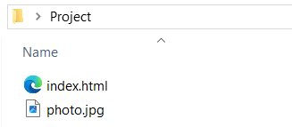
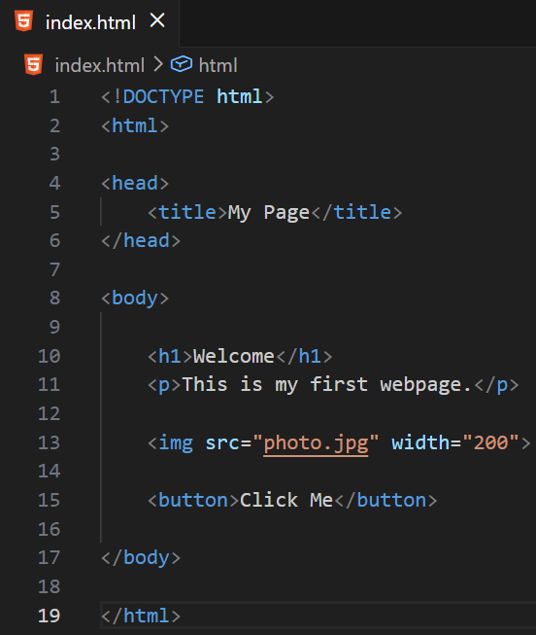
<!DOCTYPE html>
<html>

<head>
<title>My Page</title>
</head>

<body>

<h1>Welcome</h1>
<p>This is my first webpage.</p>

<img src="photo.jpg" width="200">

<button>Click Me</button>

</body>

</html>
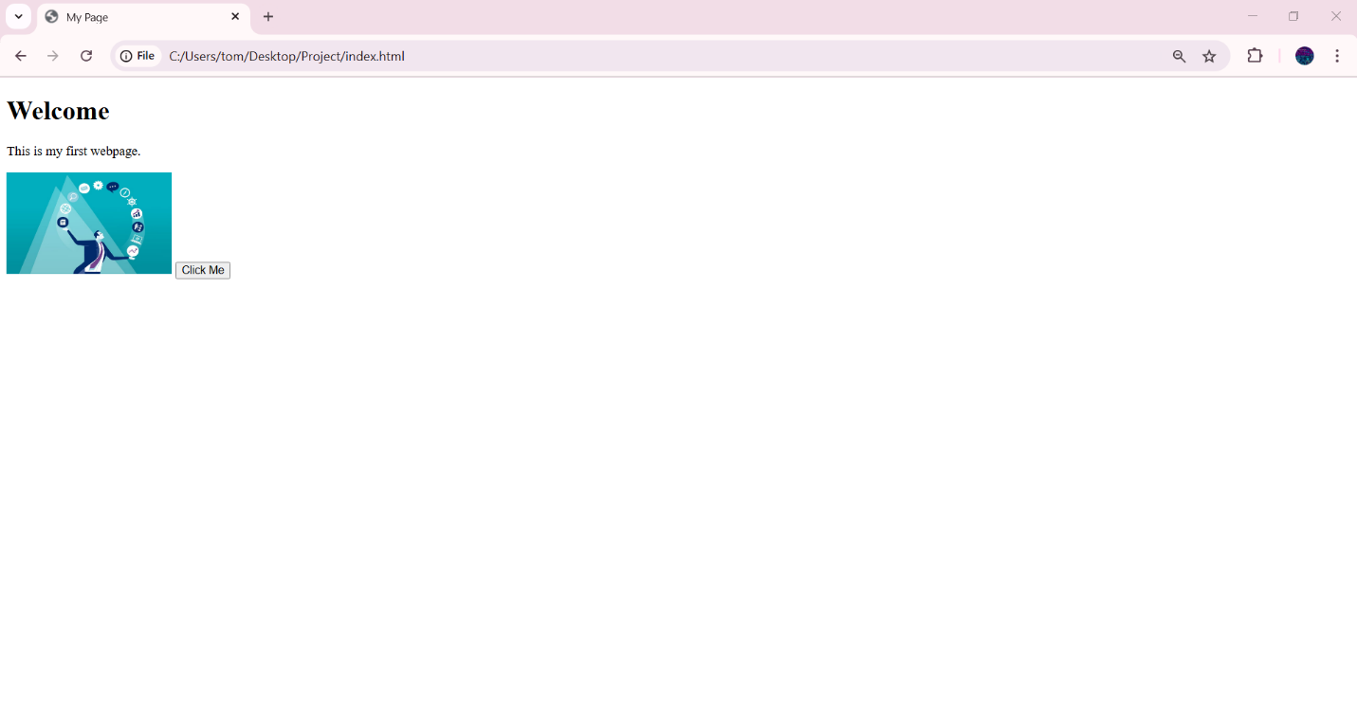

🧠 How it works
# Source: AI Source: Provided by: [Data Path: Persons Table -> ID Column: 1, Name_En Column: Motasem Essam] -> From: [ChatGPT] on [5/6/2026]
- <head> → hidden information (title, meta, CSS links)
- <body> → visible content shown to the user

⚙️ Common Elements inside <body>
# Source: AI Source: Provided by: [Data Path: Persons Table -> ID Column: 1, Name_En Column: Motasem Essam] -> From: [ChatGPT] on [5/6/2026]
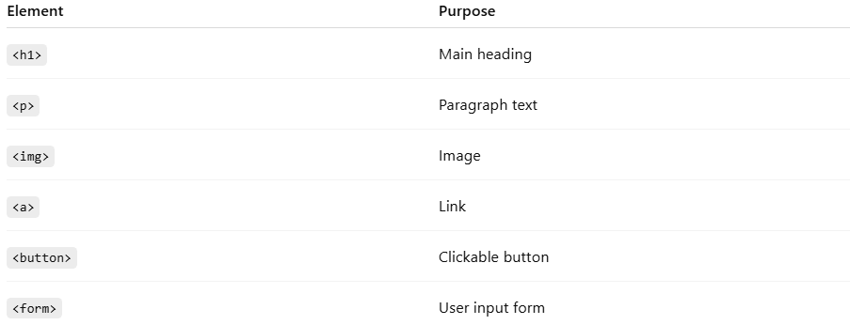
Element | Purpose
<h1> | Main heading
<p> | Paragraph text
<img> | Image
<a> | Link
<button> | Clickable button
<form> | User input form

🚫 What NOT to put in <body>
# Source: AI Source: Provided by: [Data Path: Persons Table -> ID Column: 1, Name_En Column: Motasem Essam] -> From: [ChatGPT] on [5/6/2026]
- ❌ <meta>
- ❌ <title>
- ❌ <link> (CSS links belong in <head>)
- ❌ <style> (usually in <head>)

🚀 In short:
# Source: AI Source: Provided by: [Data Path: Persons Table -> ID Column: 1, Name_En Column: Motasem Essam] -> From: [ChatGPT] on [5/6/2026]
The <body> element is the part of an HTML page that contains everything users see and interact with on the screen.

